I've made a series of screenshots (in numbered order) to show you the method for switching a page's subsite group:
Step 0 – go into the page's back end (edit mode), for example:
https://col.ed.ac.uk/node/146136/edit
Step 1 – click into the Group tab on the right-hand end of the set of tabs:
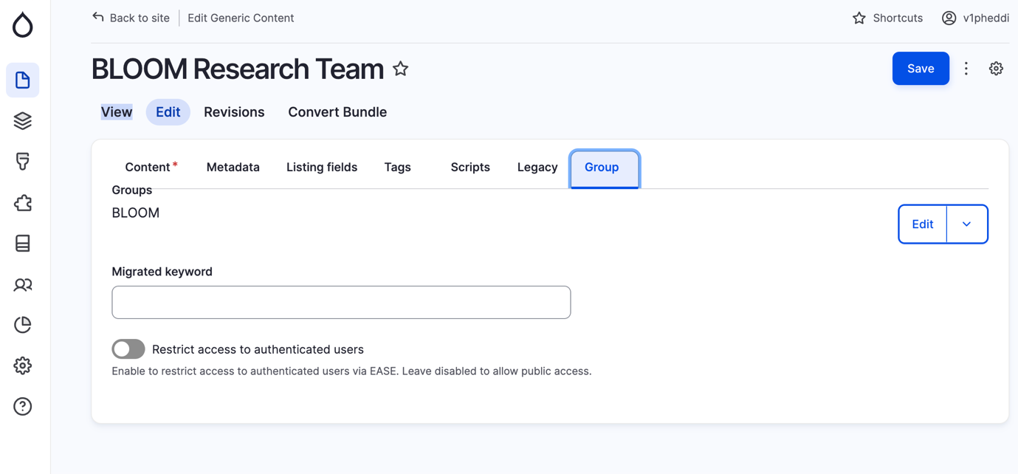
Step 2 – click on the chevron next to the Edit button on the right. Then select Remove.
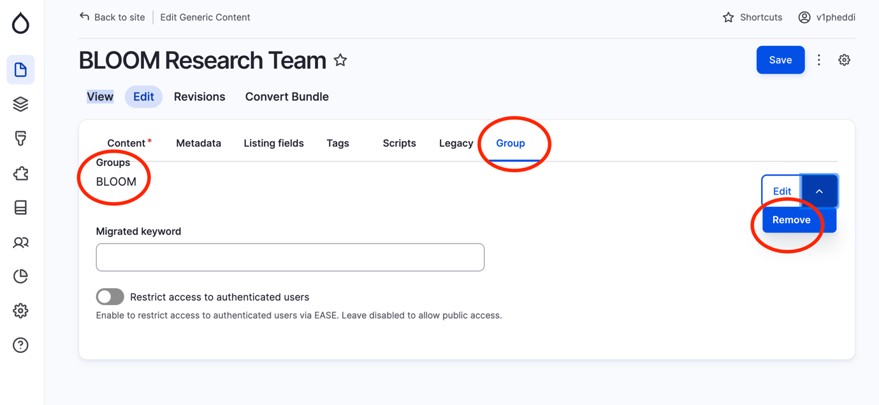
Step 3 – Click on Confirm removal. It now shows "Deleted" on the left.
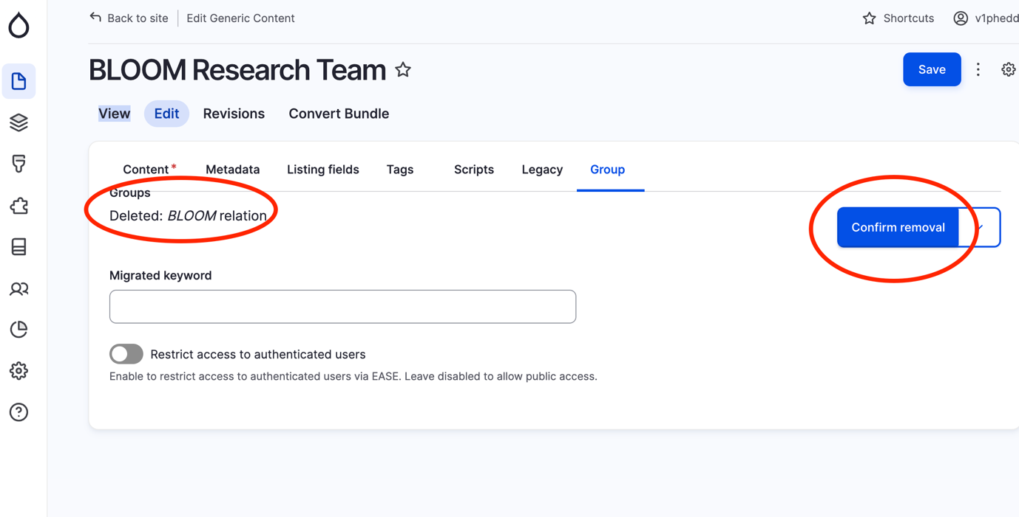
Step 4 – The "select a group" dropdown menu now appears. Click into it.
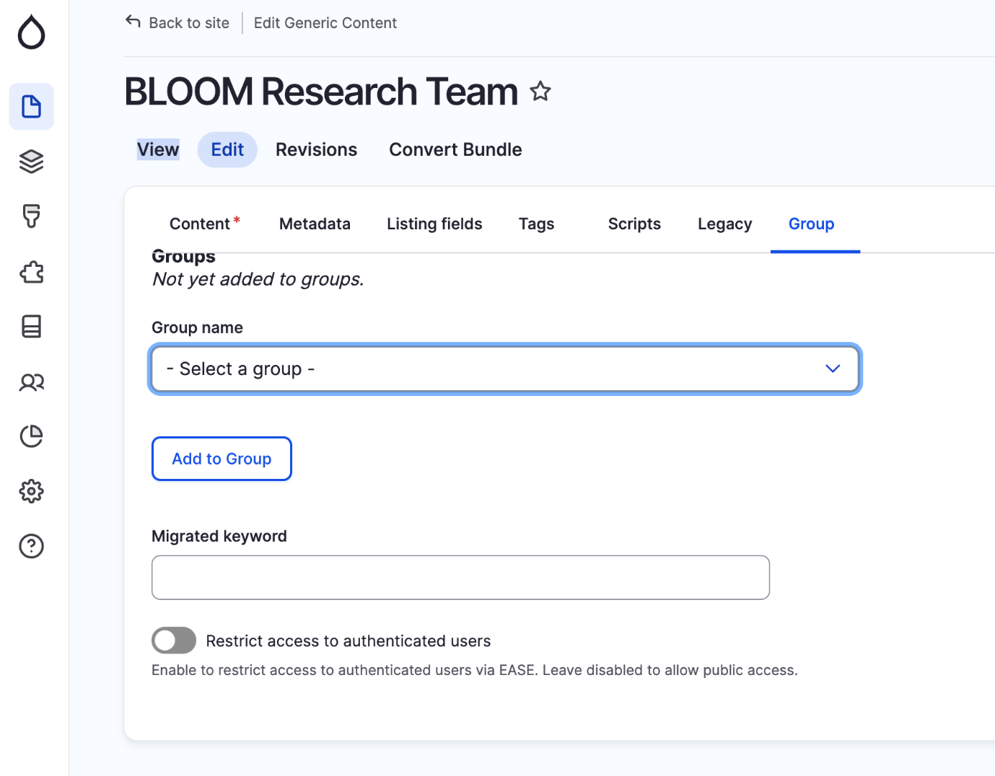
Step 5 – select the appropriate subsite parent homepage, e.g. GAFS
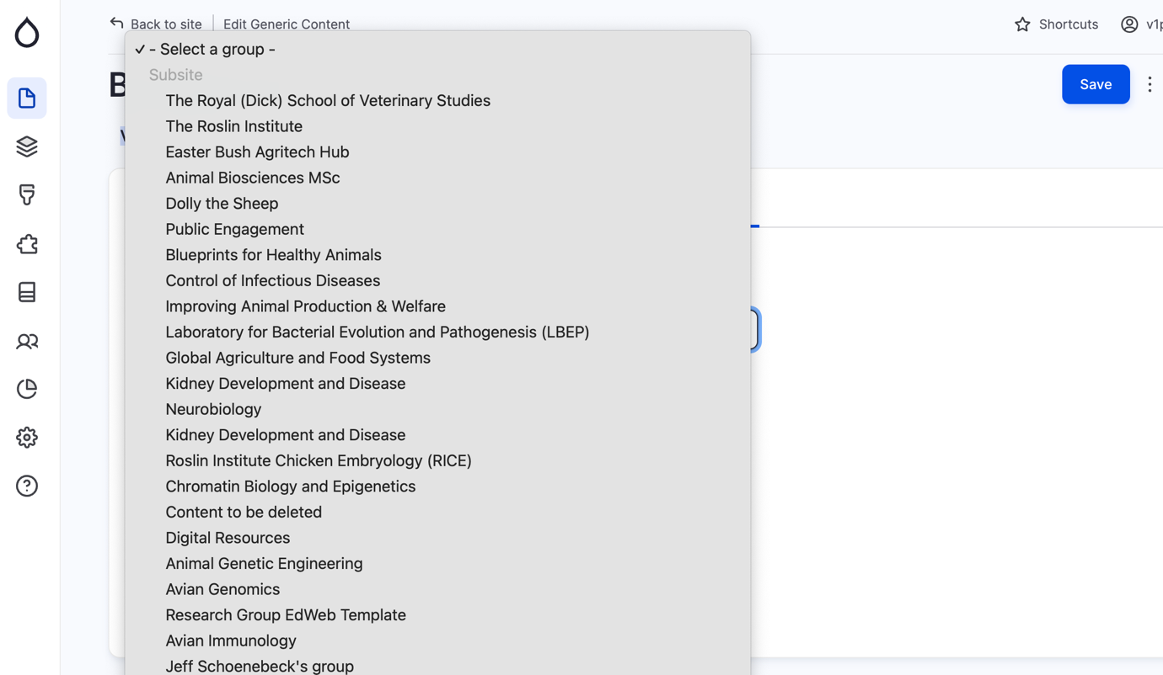
Step 6 – Click on the "Add to Group"button underneath. Click Save.
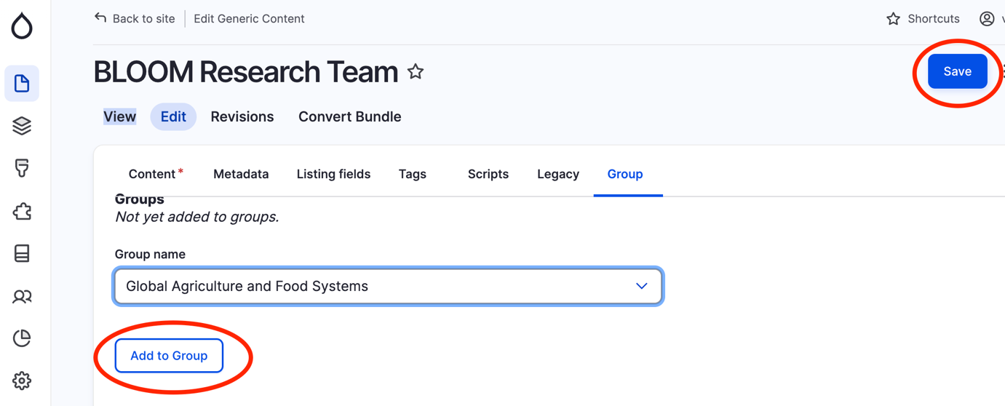
Step 7 – go back into the page and you should now see the new Group if you go to the Group tab again.
Also, switch off the old menu toggle on the right to clear any reference to the old subsite. Save page again.
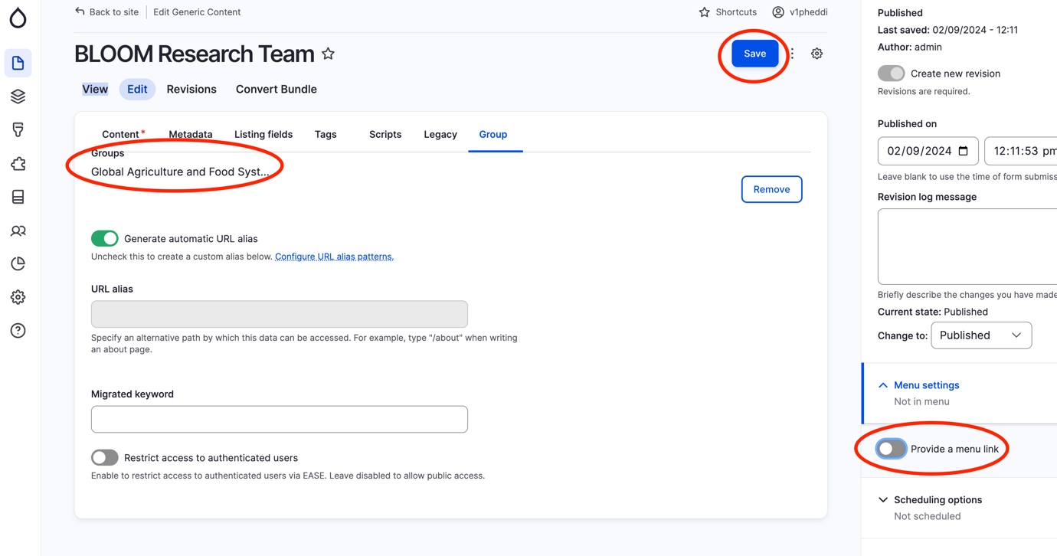
Step 8 – go back into page again and reenable the green toggle on the right for "provide a menu link".
Select the appropriate landing page from the "Parent link" dropdown underneath.
Save the page again.
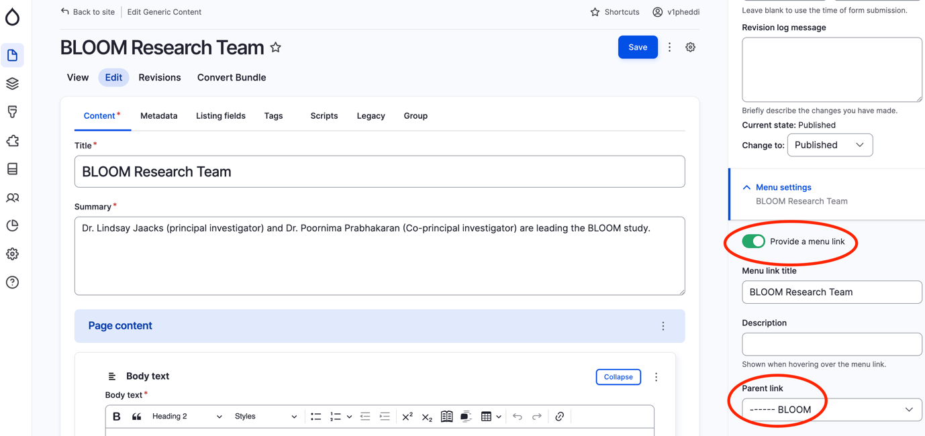
Step 9 – Check the front end of the page, to ensure that menu location, URL alias and breadcrumb all match one another.

